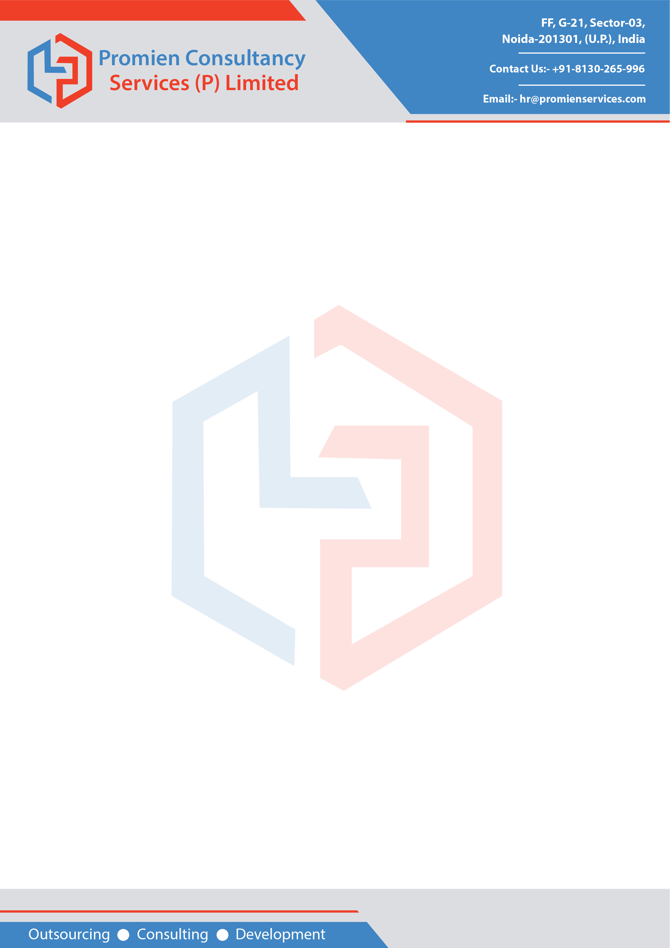

Date: 24-Nov, 2020

TO WHOMSOEVER IT MAY CONCERN

This is to certify that Ms. Deepti Bhatane, EmpId PC-2251 was associated with us from 01-Mar, 2018 to 24-Nov, 2020. At the time of leaving the company’s services, she was designated as “SQL Developer”. She has been relieved of her duties and responsibilities on close of business on 24-Nov, 2020. We appreciate the contribution made by her during the tenure with “Promien Consultancy Services (P) Ltd.”.

We wish her all the best in her all future endeavours.

For: Promien Consultancy Services (P) Ltd.

Ravinder Pal
(Manager-Human Resources)



Cc: Personal File

